ONLINE PRESENCE DOCUMENTATION
Final Year Capstone Project
Student Name: Moses Kamau
Registration Number: C025-01-2511/2021
Program: Bachelor of Science in Information Technology
University: Dedan Kimathi University of Technology
Date: February, 2026

EXECUTIVE SUMMARY
This document provides comprehensive documentation of my professional online presence across key platforms relevant to information technology professionals. Each platform serves a specific purpose in building my professional identity, showcasing my technical skills, networking with industry professionals, and contributing to the tech community.
Primary Focus Areas: Software Development, Mobile Applications, African Tech Innovation
Professional Brand: African IT Professional focused on contextually appropriate technology solutions

PLATFORM 1: LINKEDIN
Platform Overview
Platform: LinkedIn
Profile URL: [www.linkedin.com/in/moses-kamau-b08b463ab]
Account Status: Active and Updated
Date Joined: [2026]
Last Updated: [2026]
Key Profile Information
Current Headline:
Final Year IT Student at DeKUT | Full-Stack Developer | Building B-FIT GYM Manager
Featured Projects:
- B-FIT GYM Manager
Key Skills Listed:
- Skill 1 - React.js
- Skill 2 - Node.js
- Skill 3 - Mobile Development
Professional Value
How I Use LinkedIn:
I use LinkedIn to connect with tech professionals in Kenya and internationally, follow companies I'm interested in working for, and share my learning journey and project updates. It serves as my professional resume visible to recruiters and potential employers.
Screenshot File:
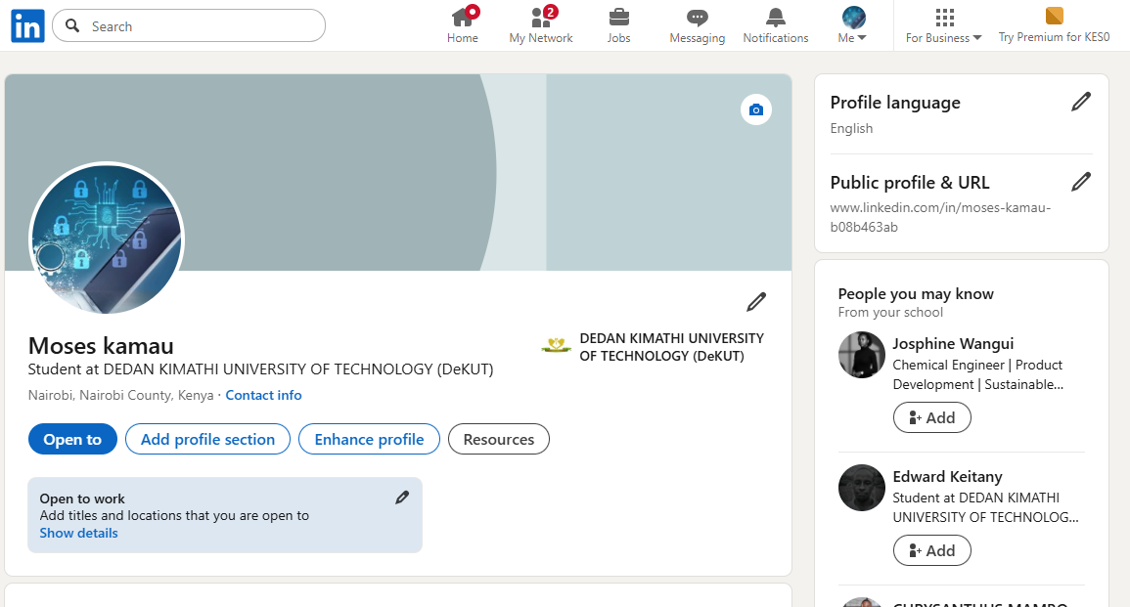

PLATFORM 2: GITHUB
Platform Overview
Platform: GitHub
Profile URL: [github.com/moseskamau21]
Account Status: Active
Date Joined: [2026]
Last Active: [2026]
Key Repositories
Repository 1: CAPSTONE
- URL: [https://github.com/moseskamau21/capstone-portfolio]
GitHub Bio:
IT Student @DeKUT | Full-Stack Developer | Building solutions for African markets
Professional Value
How I Use GitHub:
GitHub serves as my technical portfolio, showcasing my coding abilities to potential employers. I use it for version control on all my projects, to collaborate with classmates on group projects, and to demonstrate my coding consistency through regular commits. It's the primary platform where I store and share my code.
Screenshot Location
Screenshot File:
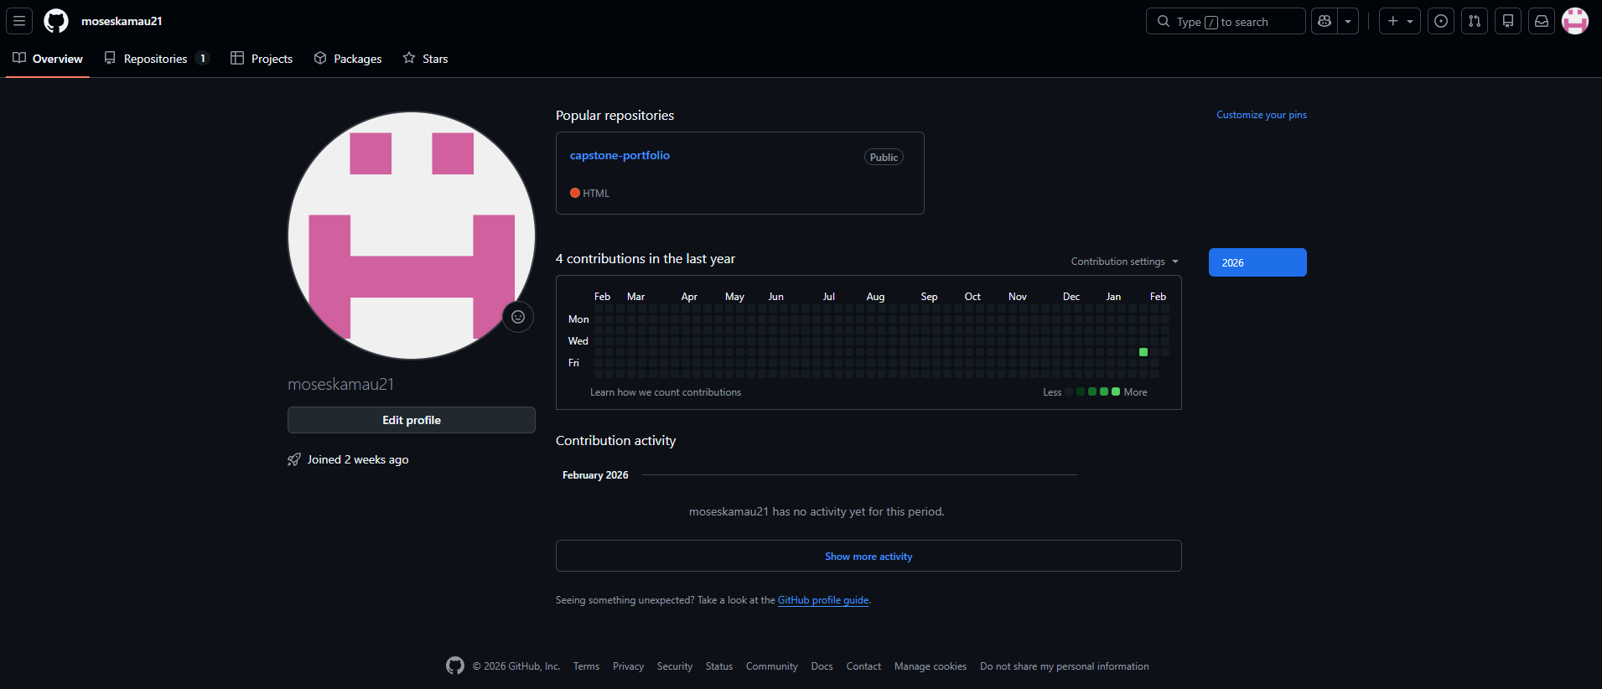

PLATFORM 3: PROFESSIONAL TWITTER/X / DEV COMMUNITY
Platform Overview
ACCOUNT:
Date Joined: 2026
FOR TWITTER/X:
- Handle: @[Kamau21Moses]
- Account Focus: Tech discussions
Bio:
Full Stack Development A.I
Professional Value
How I Use This Platform:
I use Twitter to follow tech influencers and companies, stay updated on industry trends, and occasionally share my learning progress. It helps me feel connected to the broader tech community beyond my university.
Screenshot File:
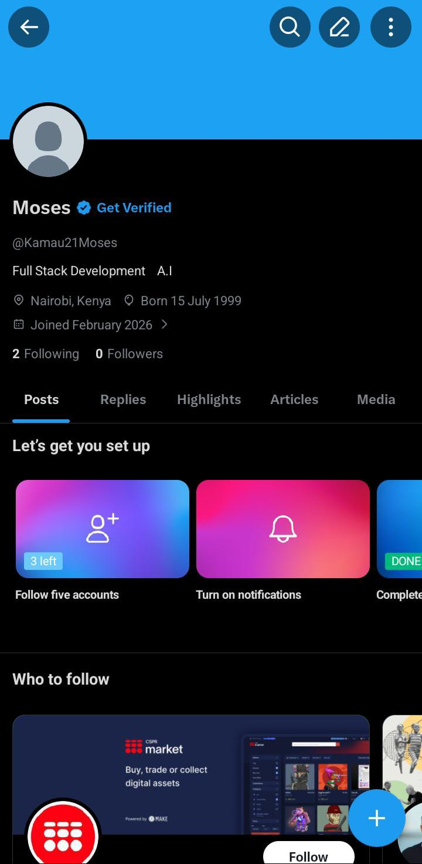
ONLINE PRESENCE STRATEGY
Overall Approach
Professional Brand Identity:
I position myself as an emerging full-stack developer focused on building practical, contextually appropriate solutions for African markets. My online presence emphasizes mobile-first development, M-Pesa integration, and the intersection of technology with African culture and values. I aim to be known as someone who understands both technical excellence and local context.
Content Themes Across Platforms:
- Technical Projects: Showcasing B-FIT and other development work
- Learning Journey: Sharing what I'm learning and challenges I'm overcoming
- African Tech: Discussing technology innovation in African context
- Community: Helping others, answering questions, sharing resources
Platform-Specific Roles:
- LinkedIn: Professional networking and job opportunities
- GitHub: Technical portfolio and code showcase
- Twitter/Dev Community: Quick updates, networking, and learning in public

DECLARATION\
I declare that all information provided in this online presence documentation is accurate and represents my genuine professional digital footprint as of the date mentioned above.
Date: February, 2026

